Kate Halstead
K.E.Halstead2@newcastle.ac.uk

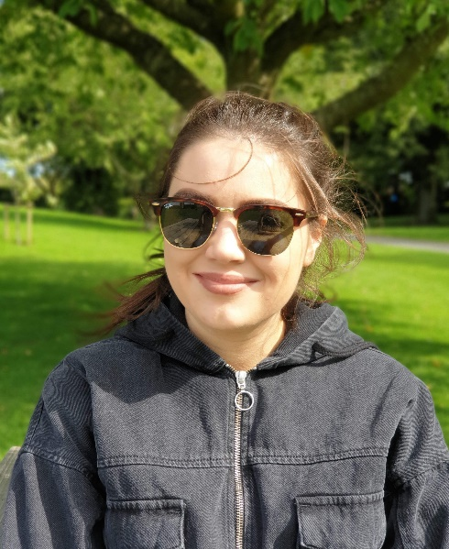
Oak trees are an iconic and essential component of the UK’s treescape, holding a special place in the public consciousness. Yet, in recent years, oak populations have vastly decreased. Given an increasing number of threats, there is concern for their health, longevity, and future. Much is a stake, as the UK’s two native oak species, Quercus robur and Quercus petraea, form the largest component of native broadleaf woodland and have the potential to store more carbon than other tree species due to being long-lived. I’m interested in investigating how these threats such as environmental factors, climate change and pests and diseases, are impacting the UK’s current and future oak populations. An understanding of which factors drive oak health, will help me to suggest interventions to alleviate stresses and provide stakeholders with data to evaluate forest management techniques.

My PhD is partnered with the Action Oak initiative.

Research Questions

The primary focus of my PhD is to investigate the distribution and demography of the UK’s native oak population, to address this research gap and identify regions where oaks are particularly at risk. The generalised objectives of the project are:
- Characterise the oak population using existing sources and develop novel surveying techniques to quantify oak health and carbon sequestration
- Identify and analyse the key drivers influencing oak health
- Implement relevant recommendations to enable further research and sustainable oak forest management.

Techniques

I’m going to be synthesising a range of skills and data sources including large-scale datasets, GIS, programming, modelling and field validation work. I will also develop models to identify regions of the UK where oaks are potentially susceptible or alternatively doing relatively well, in response to current and future predictions of climatic conditions. Characterising the oak population will entail quantifying current and predicted levels of carbon sequestration, due to the link with climate change. To do this, I will explore remote sensing techniques and utilise low-cost UAV platforms equipped with LiDAR technology to estimate carbon sequestration in current and future oak populations.

Supervisors

Dr Rachel Gaulton, Newcastle University
Dr Roy Sanderson, Newcastle University
Sarah Jeffery, Action Oak

